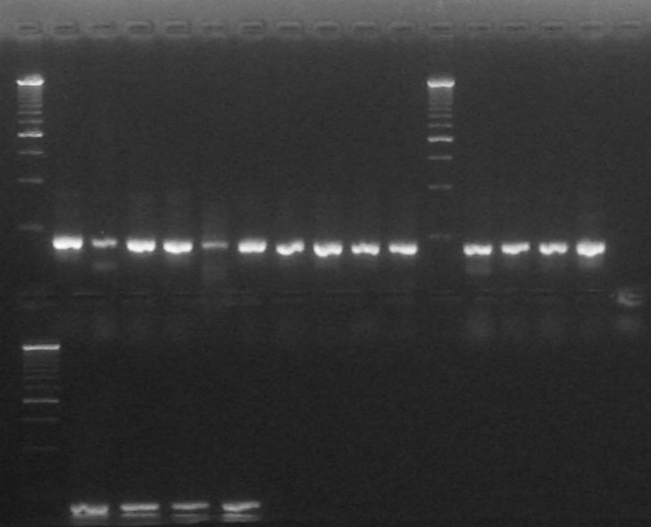

**1 2 3 4 5 6**

**1 2 3 4 5 6 7 8 9 10 11 12 13 14 15 16 17**

Arriba

Calle 1: Ladder 250pb

Calle 2: Colony PCR G4 #1

Calle 3: Colony PCR G4 #2

Calle 4: Colony PCR G4 #3

Calle 5: Colony PCR G4 #4

Calle 6: Colony PCR G4 C-

Calle 7: Colony PCR G3 #1

Calle 8: Colony PCR G3 #2

Calle 9: Colony PCR G3 #3

Calle 10: Colony PCR G3 #4

Calle 11: Colony PCR G3 C-

Calle 12: Ladder 250pb

Calle 13: Colony PCR G2 #1

Calle 14: Colony PCR G2 #2

Calle 15: Colony PCR G2 #3

Calle 16: Colony PCR G2 #4

Calle 17: Colony PCR G2 C-

Abajo

Calle 1: Ladder 250pb

Calle 2: Colony PCR G1 #1

Calle 3: Colony PCR G1 #2

Calle 4: Colony PCR G1 #3

Calle 5: Colony PCR G1 #4

Calle 6: Colony PCR G1 C-

**1 2 3 4 5 6 7**